Objectives:

* Using the IF Block Structure
* Using the Write and Read methods
* **There are 2 challenge exercises, each worth 50%**

Please submit this document for grading when completed… Please work in-groups.

**Project #1** (Comparing Strings)

**Project #2 (**Using the nested if statement)

**Challenge Exercise #1:** complete the following program using the if block structure

**#1 print screen the output with the code below here**

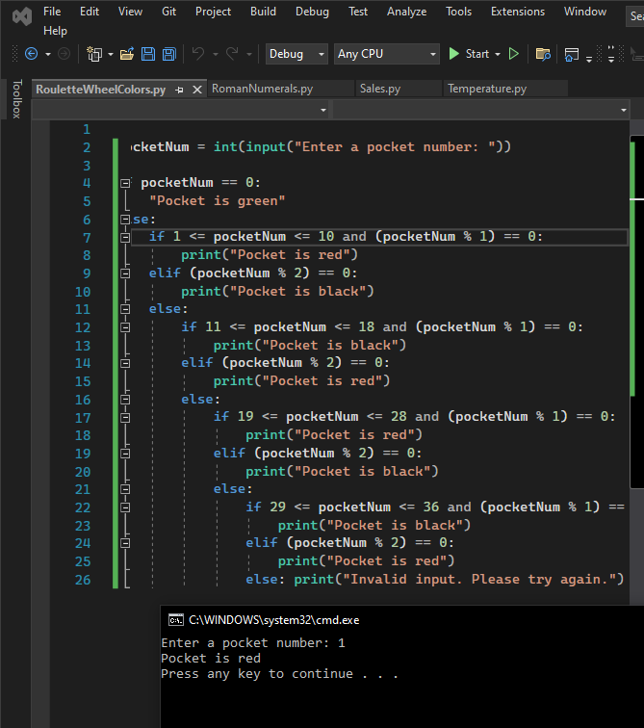

**Challenge Exercise #2:** complete the following program using the if block structure

**#2 print screen the output with the code below here**

**Submit this document to Module 2 Class Exercise**